**9: Backend Application - Create Deployment and ClusterIP Service**

--- **Reference** - https://github.com/stacksimplify/kubernetes-fundamentals/tree/master/10-Services-with-YAML

**Introduction to Services**

--- We are going to look in to below two services in detail with a frontend and backend example

1. **NodePort Service**
2. **ClusterIP Service**

**Create Backend Deployment & Cluster IP Service**

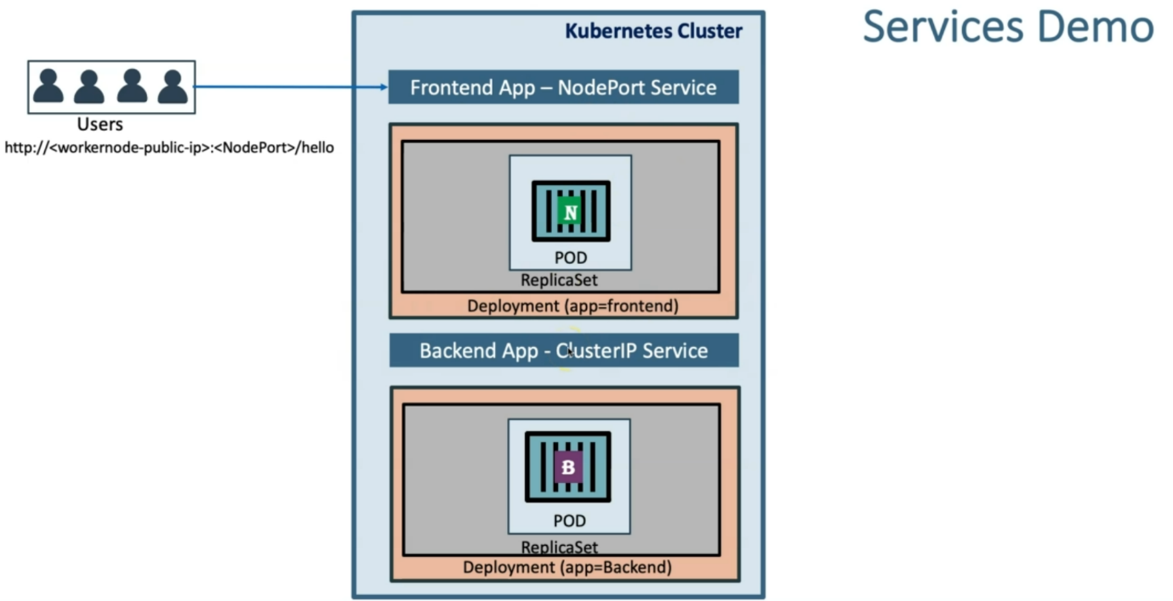

--- **note** – this is what we developed using imperative way. Now we will develop same using declarative way.

--- **note** – we are going to create manifest for backend deployment and backend cluster ip service and frontend deployment and frontend nodeport service.

--- **Write the Deployment template for backend REST application.**

apiVersion: apps/v1

kind: Deployment

metadata:

  name: backend-restapp

  labels:

    app: backend-restapp

    tier: backend

spec:

  replicas: 3

  selector:

    matchLabels:

      app: backend-restapp

  template:

    metadata:

      labels:

        app: backend-restapp

        tier: backend

    spec:

      containers:

        - name: backend-restapp

          image: stacksimplify/kube-helloworld:1.0.0

          ports:

            - containerPort: 8080

--- **Write the Cluster IP service template for backend REST application.**

apiVersion: v1

kind: Service

metadata:

  name: my-backend-service ## VERY VERY IMPORTANT - NGINX PROXYPASS needs this name

  labels:

    app: backend-restapp

    tier: backend

spec:

  #type: Cluster IP is a default service, even though if don’t mention the clusterIP, by default it will create cluster ip.

  selector:

    app: backend-restapp

  ports:

    - name: http

      port: 8080 # ClusterIp Service Port

      targetPort: 8080 # Container Port

--- **Important Notes**: Name of Cluster IP service should be name: my-backend-service because same is configured in frontend nginx reverse proxy default.conf.

--- cd <Course-Repo>\kubernetes-fundamentals\10-Services-with-YAML\kube-manifests

--- **kubectl get all**

--- **kubectl apply -f 01-backend-deployment.yml -f 02-backend-clusterip-service.yml**

--- **kubectl get all**

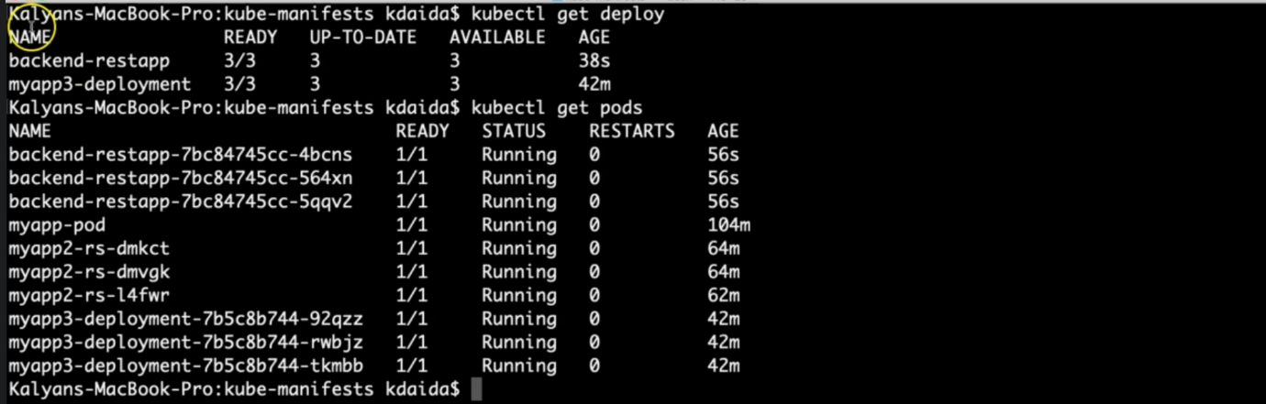

--- **kubectl -f logs -f <pod name>** - to see the pod logs.

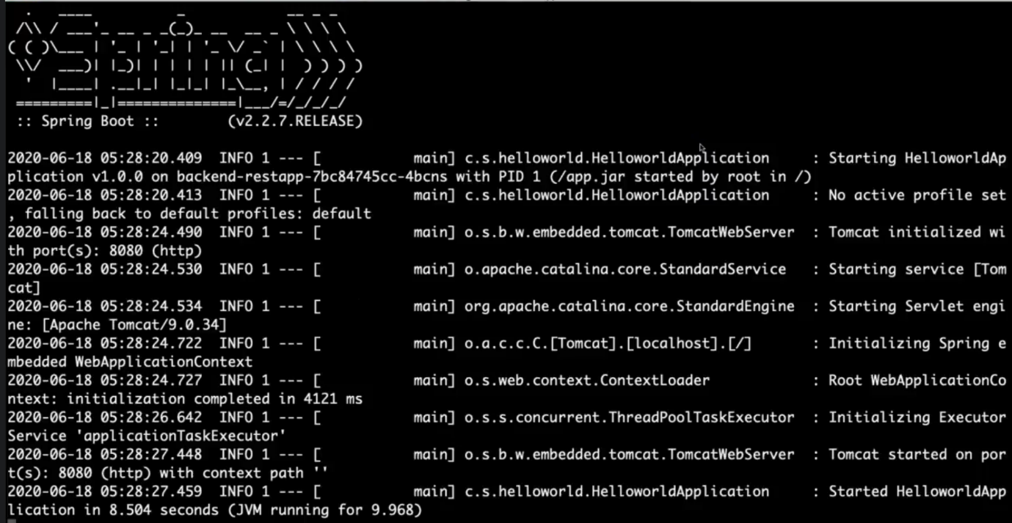

--- **note** – you can see that our backend application has started.

--- **kubectl get svc** – to list the services.

